LAB # 2

SIMULATING Method

# Objective

To become familiar with the network simulator Packet Tracer

# Theory

**Simulation**

Simulation is the imitation of some real thing, state of affairs, or process. The act of simulating something generally entails representing certain key characteristics or behaviours of a selected physical or abstract system.

Simulation is used in many contexts, including the [modeling](http://en.wikipedia.org/wiki/Scientific_modeling) of natural systems or human systems in order to gain insight into their functioning. Other contexts include simulation of [technology](http://en.wikipedia.org/wiki/Technology) for performance optimization, [safety engineering](http://en.wikipedia.org/wiki/Safety_engineering), [testing](http://en.wikipedia.org/wiki/Experiment), [training](http://en.wikipedia.org/wiki/Training) and [education](http://en.wikipedia.org/wiki/Education). Simulation can be used to show the eventual real effects of alternative conditions and courses of action.

Key issues in simulation include acquisition of valid source information about the relevent selection of key characteristics and behaviours, the use of simplifying approximations and assumptions within the simulation, and fidelity and validity of the simulation outcomes.

**Network Simulation**

All the network setup is performed on real time mode. Simulation mode is used to simulate the network to check its behavior in graphical way

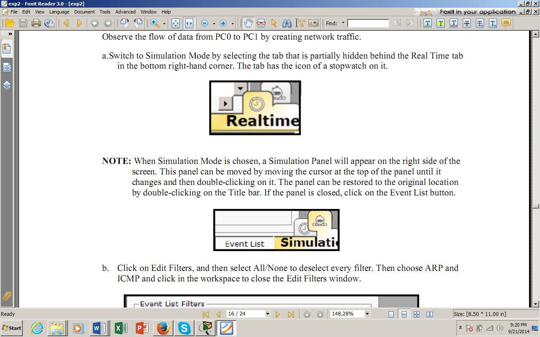 

**Fig 2.1**: Real-time and Simulation Mode

**Network Scenarios**

Multiple scenarios can be created and deleted by clicking on the New and Delete button in the scenario panel. The scenarios can be toggled between without deleting.

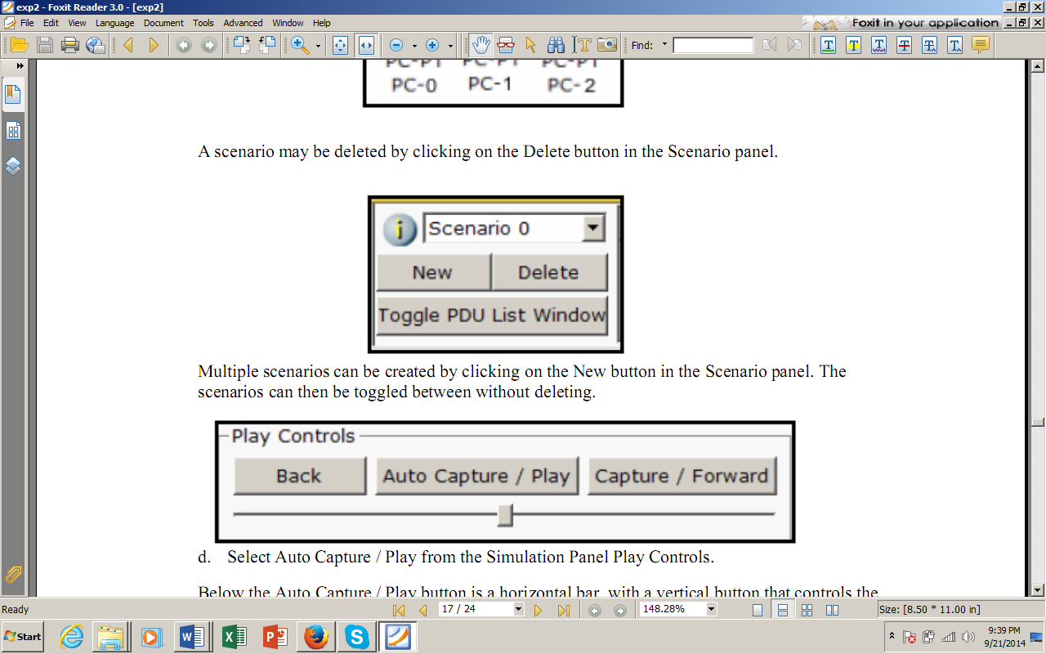

**Fig 2.2**: Scenario Panel

**RealTime Simulation**

Packet Tracer offers different methods to connect and configure devices. Most of the time, you’ll probably left-click on each device in the simulator and configure it through the CLI tab. However, you can also simulate how network engineers would provision devices in the real world. You can accomplish this by connecting a computer to each device via console cable and then configuring the network device through the PC’s terminal. You can even use this to configure remote management of the network device through Telnet or SSH, then connect the PC to a management network and configure each device remotely.

In this way, Packet Tracer provides a robust network simulator sandbox. You get to make rules regarding how “realistic” you would like your labbing session to be.

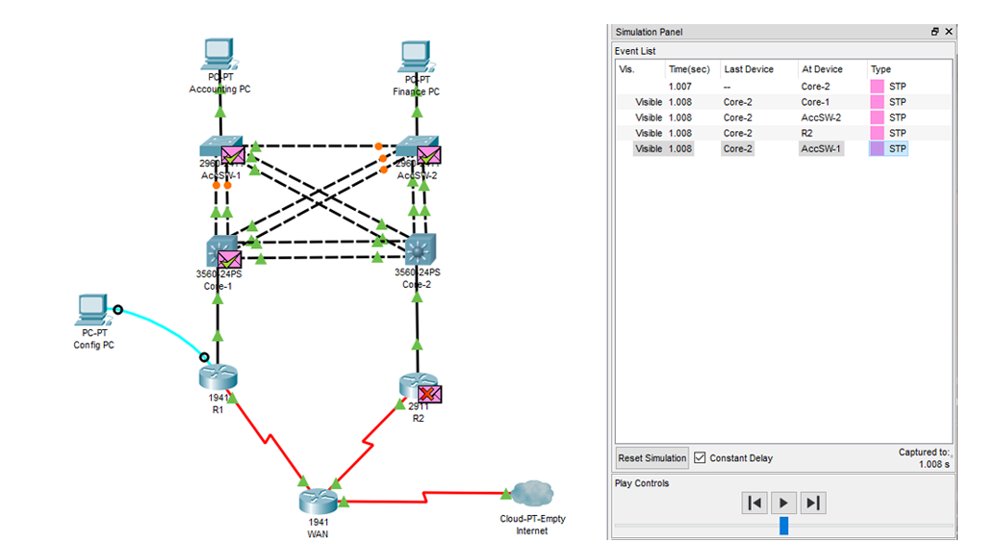

**Simulation Mode**.

Packet Tracer is your best friend when troubleshooting connectivity issues — particularly with Simulation Mode, which shows you the path of a packet through a network.

By default, Packet Tracer works in Realtime Mode. In Realtime Mode, connected network devices generate control plane traffic (such as Spanning Tree Protocol BPDUs, routing protocol Hello messages) and forward data plane traffic (such as ICMP messages and TCP/UDP packets between end hosts) in real-time, just like real network devices would. This network activity is visible in real-time through the flashing connection lights between devices, indicating that data was sent or received on a link.

However, let’s say you’re troubleshooting a connectivity issue between two end hosts. It can be difficult to visualize how the packet flows through a large network. Simulation Mode allows you to walk through the path of a packet step-by-step. You can observe attributes of the packet change and see the forwarding decision that each intermediary network device makes on the packet. With Simulation Mode you can quickly compare what’s happening on the network device’s CLI with what visually happens to the packet as it traverses their simulated network.

**Ping**

The ping command verifies connections to remote computer or computers, by sending ICMP echo packets to the computer and listening for echo reply packets. Ping waits for up to 1 second for each packet sent and prints the number of packets transmitted and received. Each received packet is validated against the transmitted message. By default, four echo packets containing 64 bytes of data (a periodic uppercase sequence of alphabetic characters) are transmitted.

You can use the ping utility to test both the computer name and the IP address of the computer. If the IP address is verified but the computer name is not, you may have a name resolution problem. In this case, be sure that the computer name you are querying is in either the local HOSTS file or in the DNS database. The Ping stands for Packet Internet Groper.

**Example 2.1**

Y:\>ping sirsyed

Output as follows:

Pinging sirsyed [192.168.1.1] with 32 bytes of data:

Reply from 192.168.1.1: bytes=32 time<10ms TTL=255

Reply from 192.168.1.1: bytes=32 time<10ms TTL=255

Reply from 192.168.1.1: bytes=32 time<10ms TTL=255

Reply from 192.168.1.1: bytes=32 time<10ms TTL=255

**Example 2.2**

Output as follows:

Y:\>ping aurangzeb

Pinging aurangzeb [192.168.1.5] with 32 bytes of data:

Reply from 192.168.1.5: bytes=32 time<10ms TTL=128

Reply from 192.168.1.5: bytes=32 time<10ms TTL=128

Reply from 192.168.1.5: bytes=32 time<10ms TTL=128

Reply from 192.168.1.5: bytes=32 time<10ms TTL=128

**Exercise 2.3**

On command prompt, type

Y:\>ping 192.168.2.145

Record the output:

___________________________________________________________

___________________________________________________________

**Exercise 2.4**

On command prompt, type

Y:\>ping 192.168.1.3

Record the output

___________________________________________________________

___________________________________________________________

**PACKET SIMULATION(CISCO PACKET TRACER 7.0)**

**Topology:**

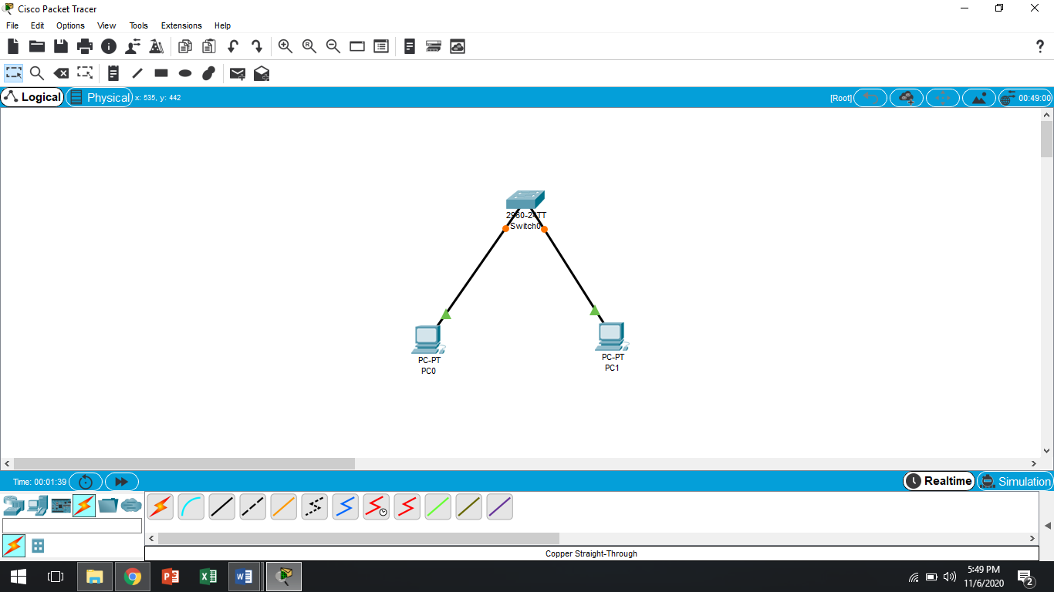

**Step 01:Assign IP’s to both PC’s**

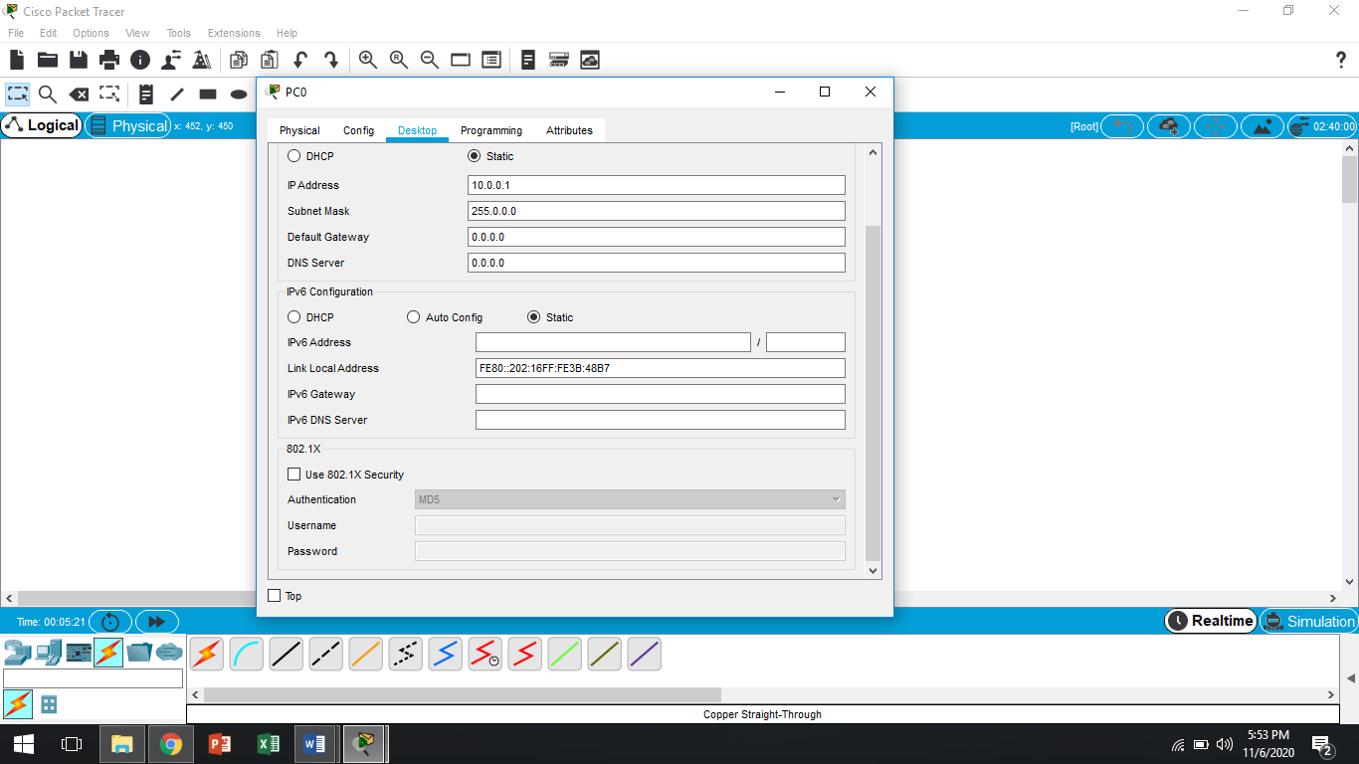

Then we have three simulation methods fir visualizing of packets movement behaviour.

1. Ping
2. Real Time
3. Simulation

* **In Ping**

**Step 02: Go to PC 🡪 Desktop tab 🡪 Command Prompt icon**

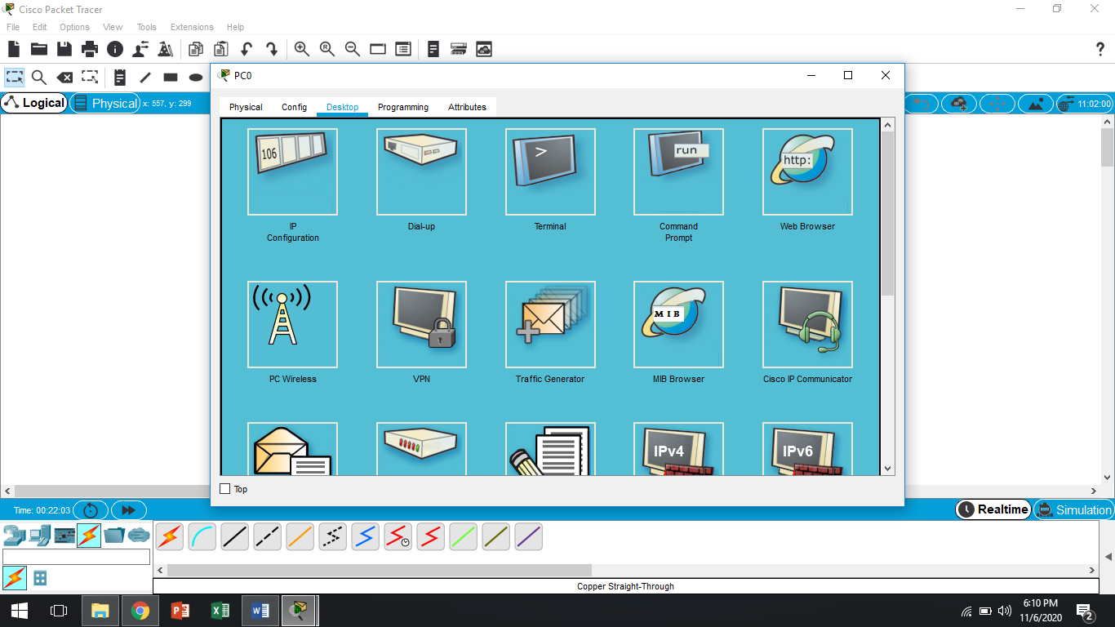

**Step 03: Ping the neighbour PC IP’s**

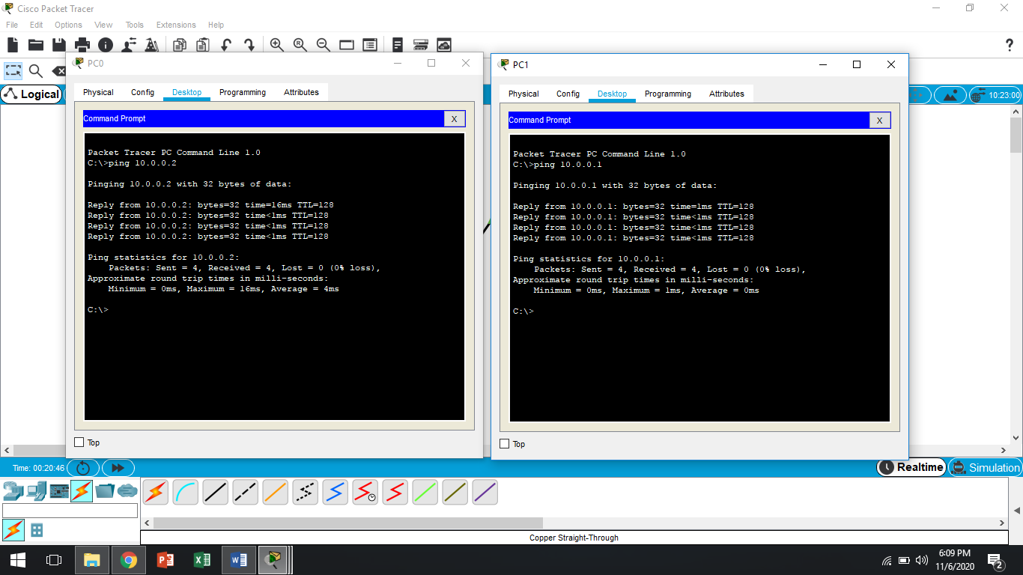

* **In Real Time**

**Step 04: PDU select 🡪 Click on one PC than on other PC**

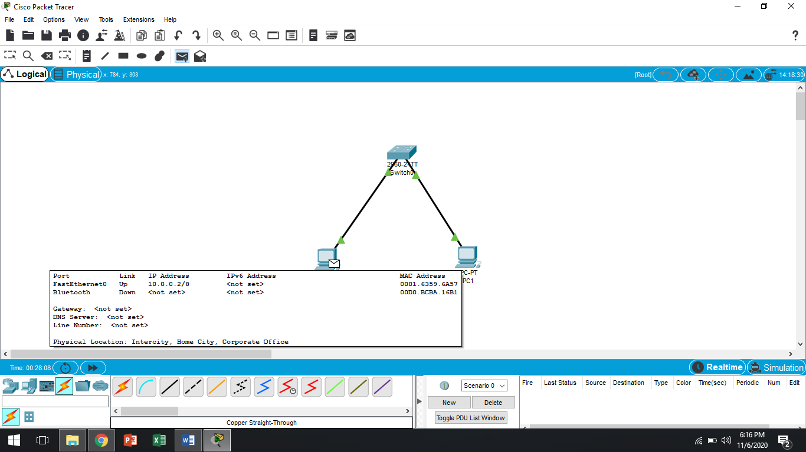

* **In Simulation**

**Step 05: First you use shift + S then click PDU and perform step 04 again.**

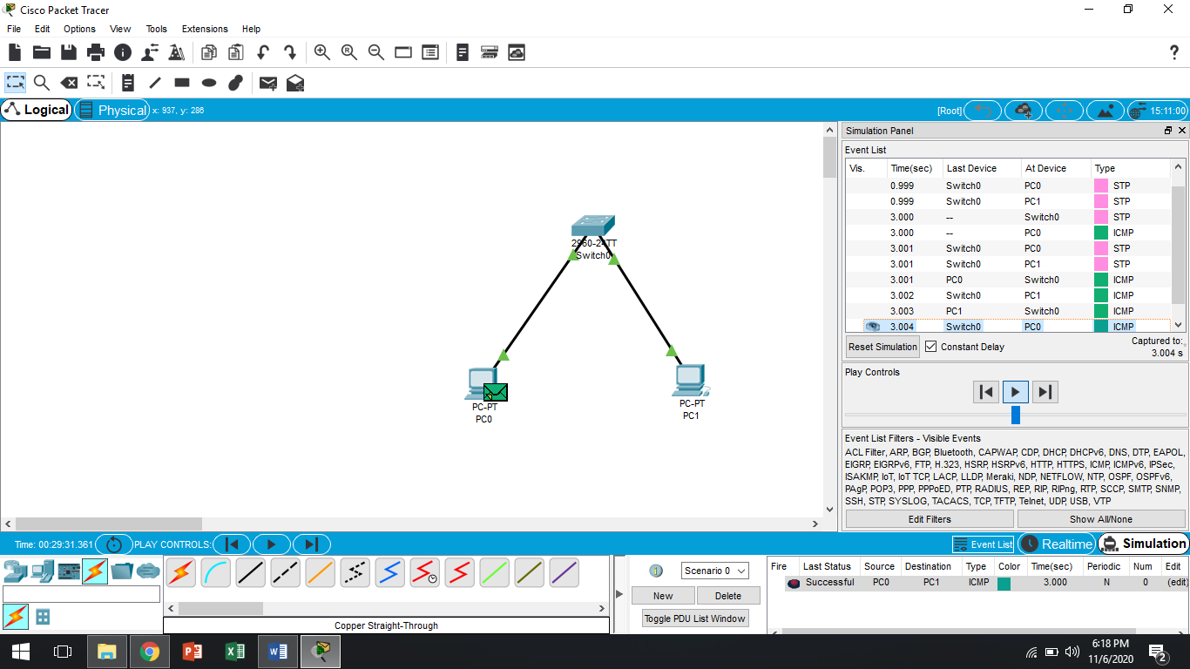

**HOME ASSIGNMENTS**

Q 1:Differentiate between three simulation method.

Q 2: Perform these simulation method connecting more than 2 PC’s.